Two Adorable Hitcher Possums Cling To The Back Of An Owner’s Dog
An Australian woman named Sally Watkinson shared a few pictures of her pet dogs on her Facebook account. The pictures caught the eyes of many people. Why? There was a ringtail possum clinging to the back of one of her Puli dogs, of course! Can you believe it?

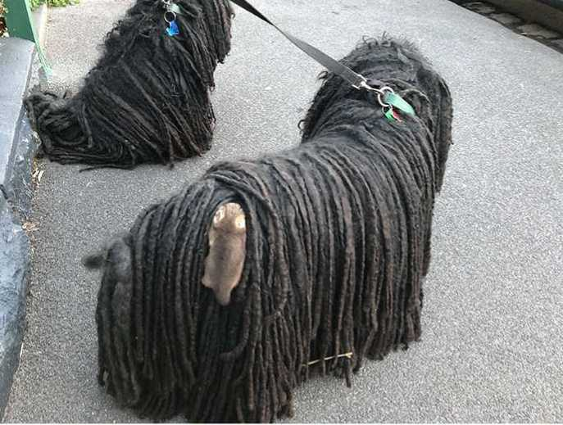
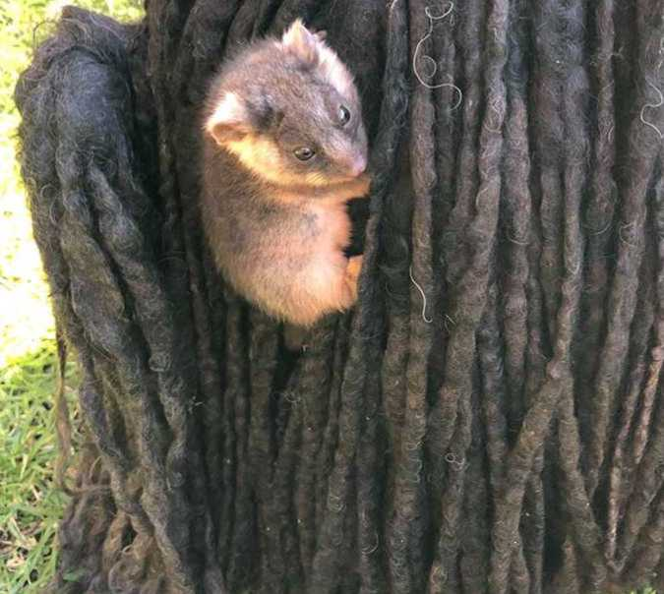
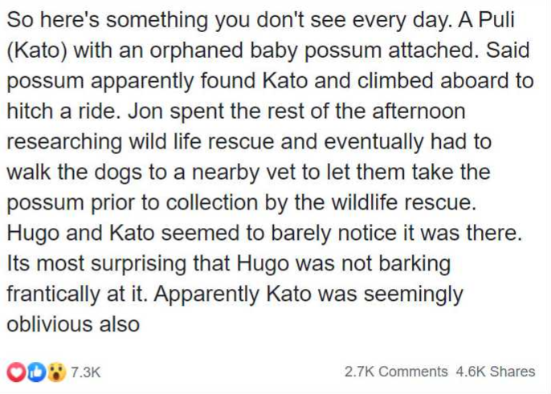

The possum was enjoying a hitch ride on the dog’s back but the dog didn’t seem to mind. What’s so unbelievable is that the next day, it happened again, only this time it was a baby boy.

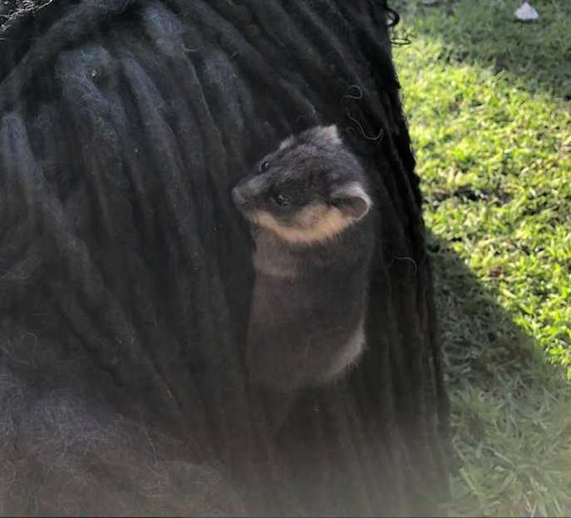

This is what Sally wrote:
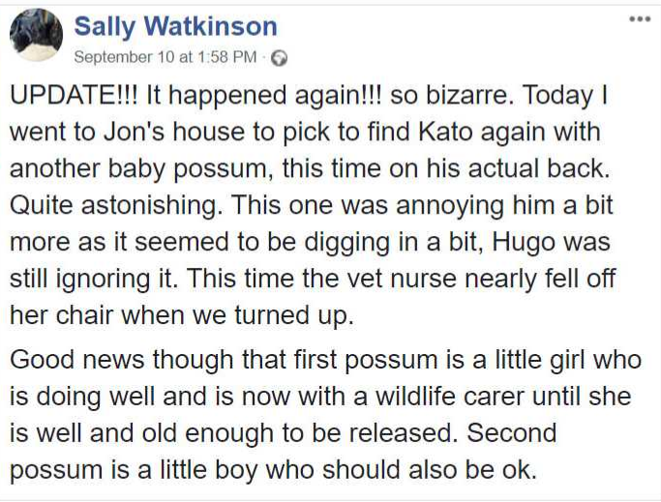

So, the two possums are healthy and they are well taken care of by The Wildlife Care Association.
People on the internet found this peculiarity fascinating and adorable and they stormed Sally’s Facebook with comments:
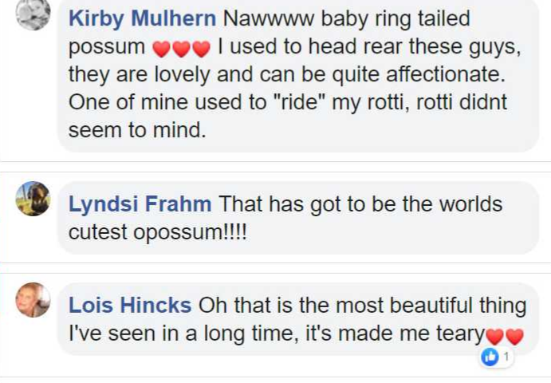 ttps://snipboard.io/ZIM264.jpg rd.io/ZIM264.jpg

